CJ301: Criminal Justice Research Methods Online Syllabus Home Page

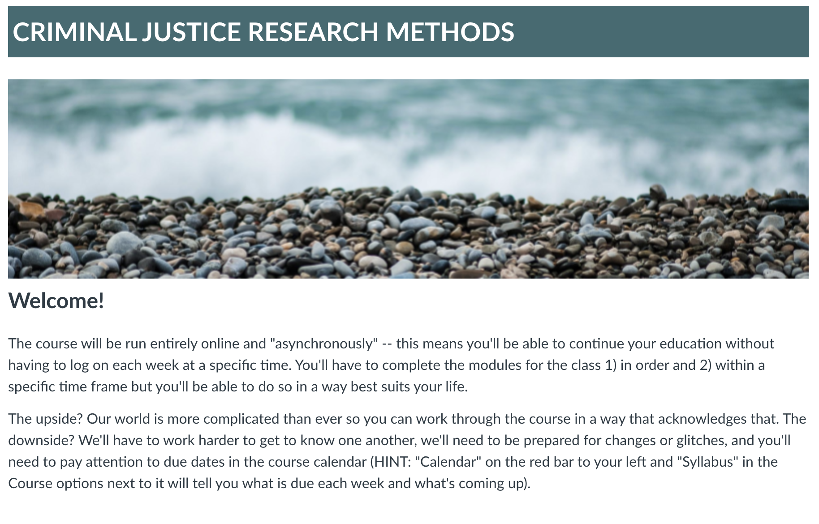
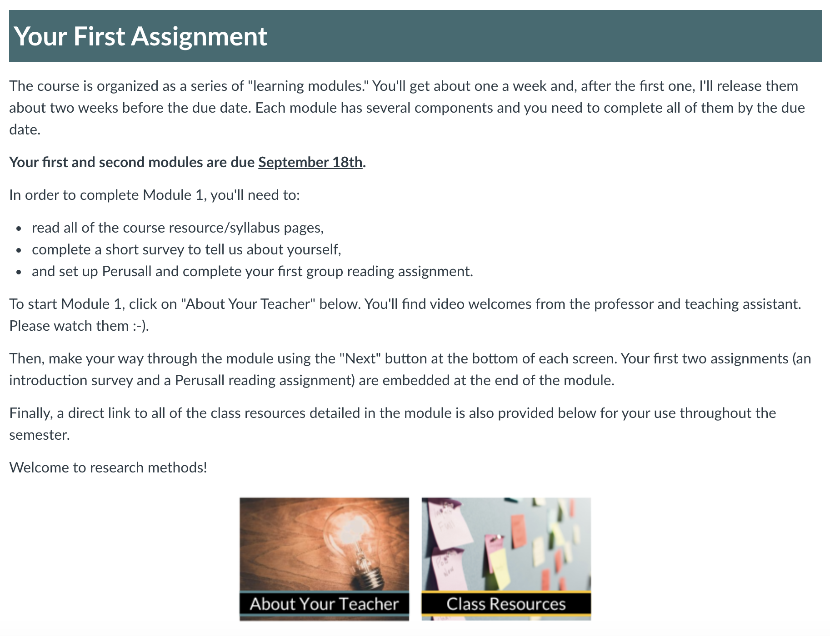
CJ301: Criminal Justice Research Methods Instructor Information

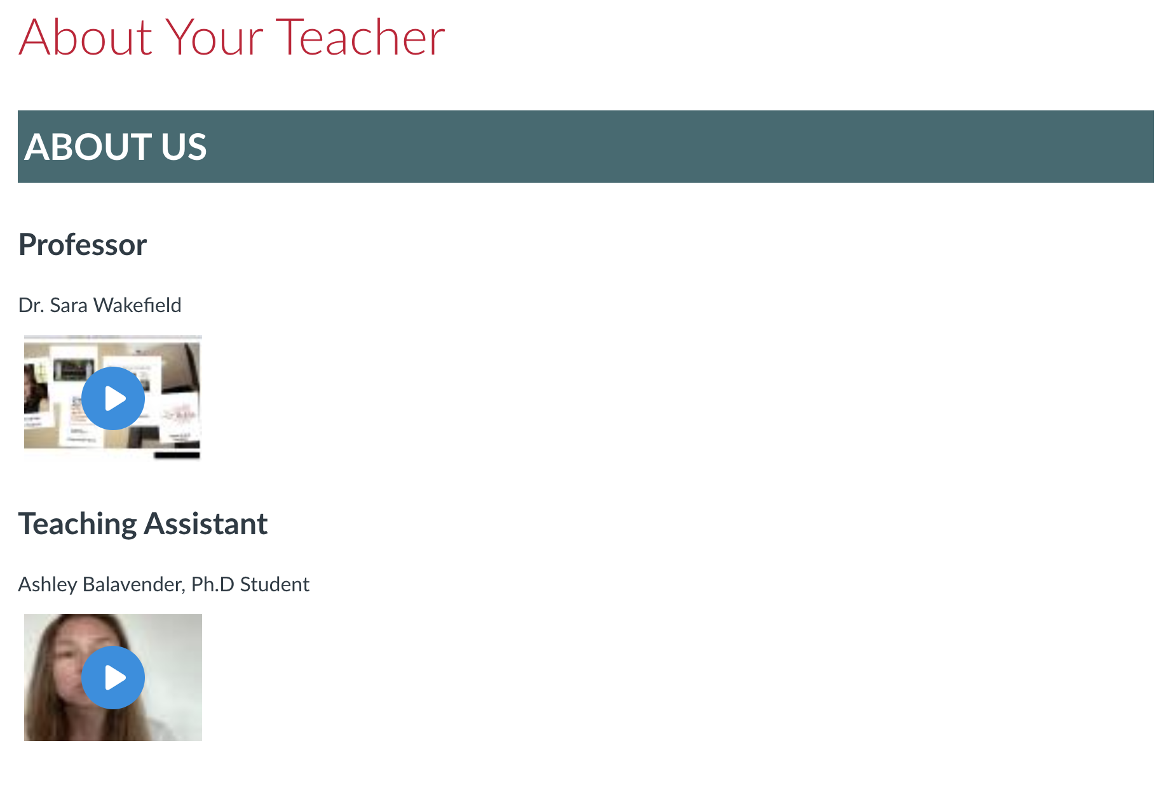
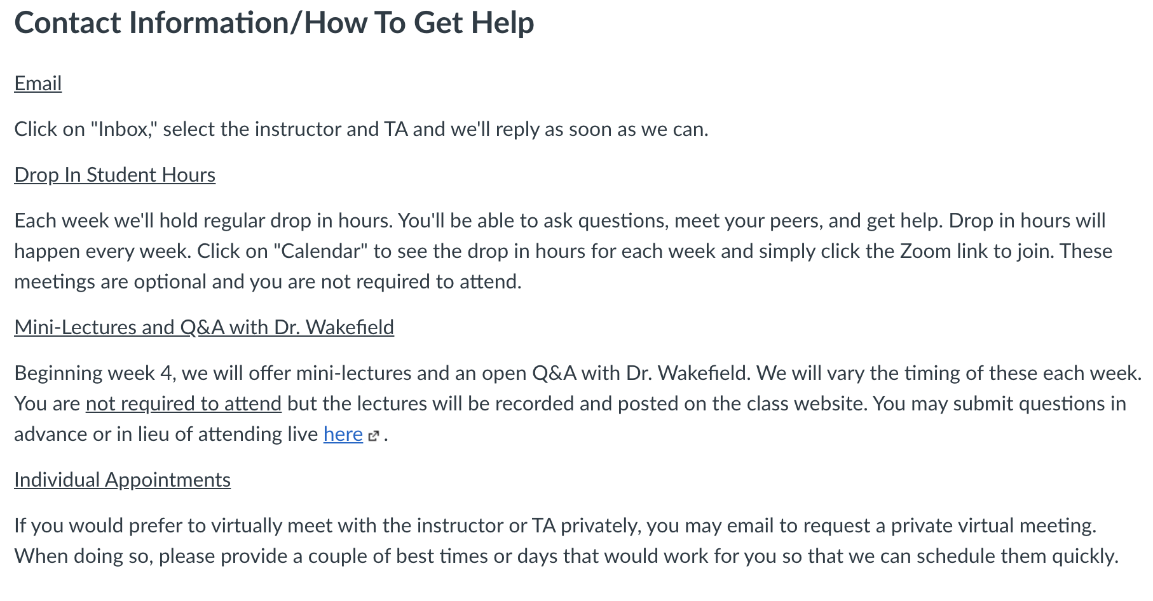

CJ301: Criminal Justice Research Methods Class Resources

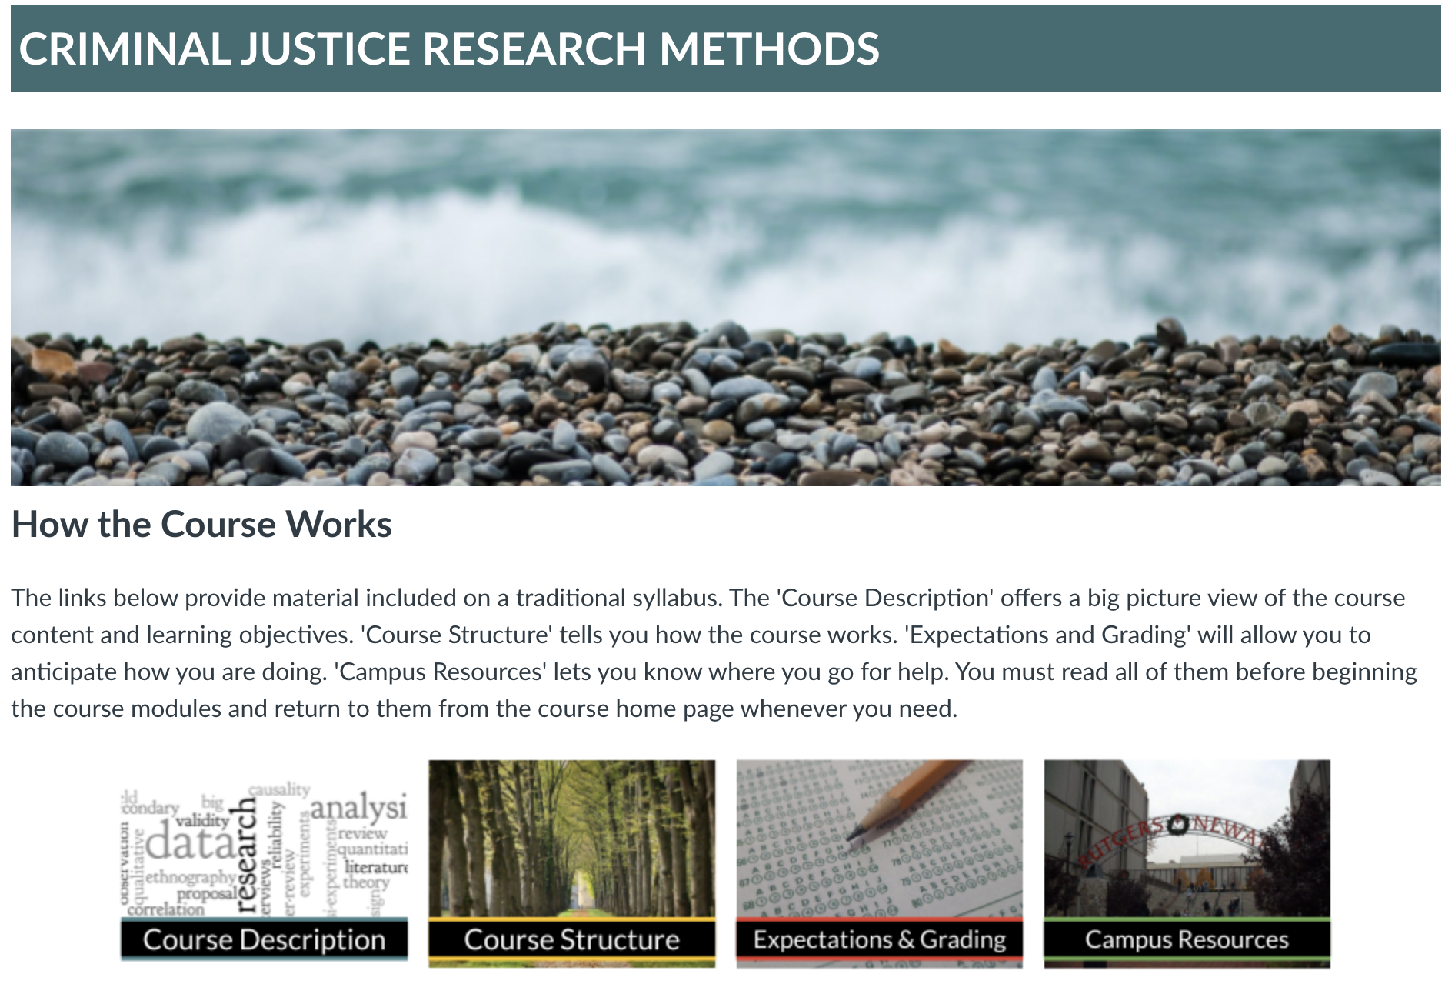

CJ301: Criminal Justice Research Methods Course Description
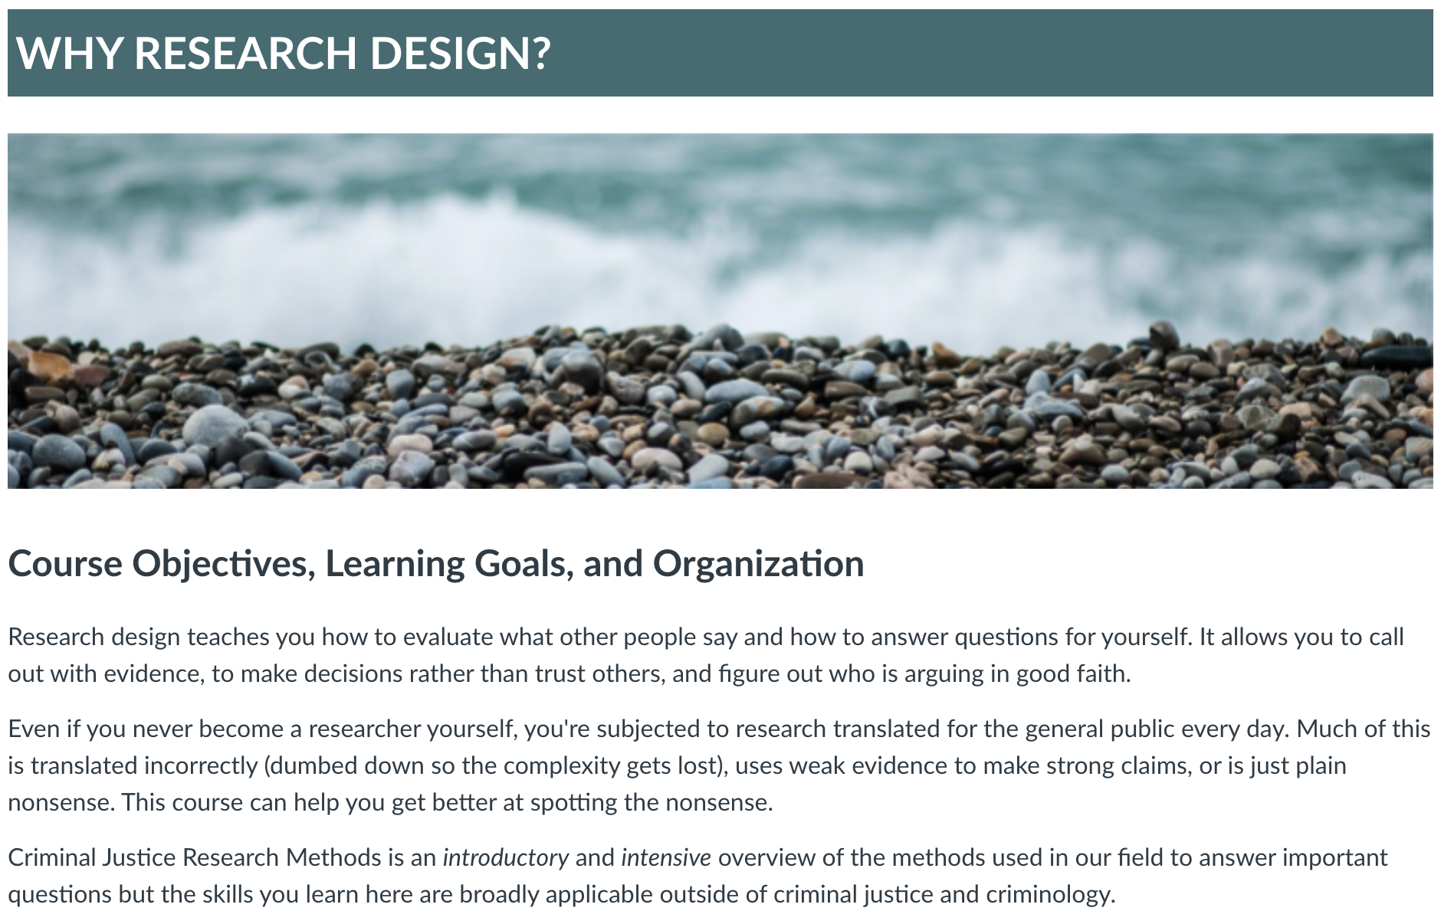

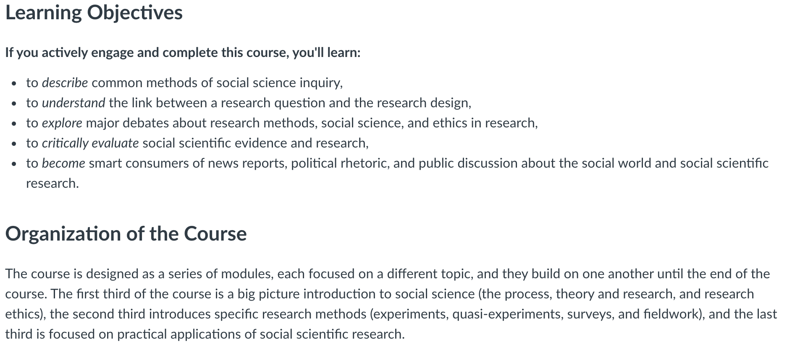

CJ301: Criminal Justice Research Methods Course Structure (1/5)
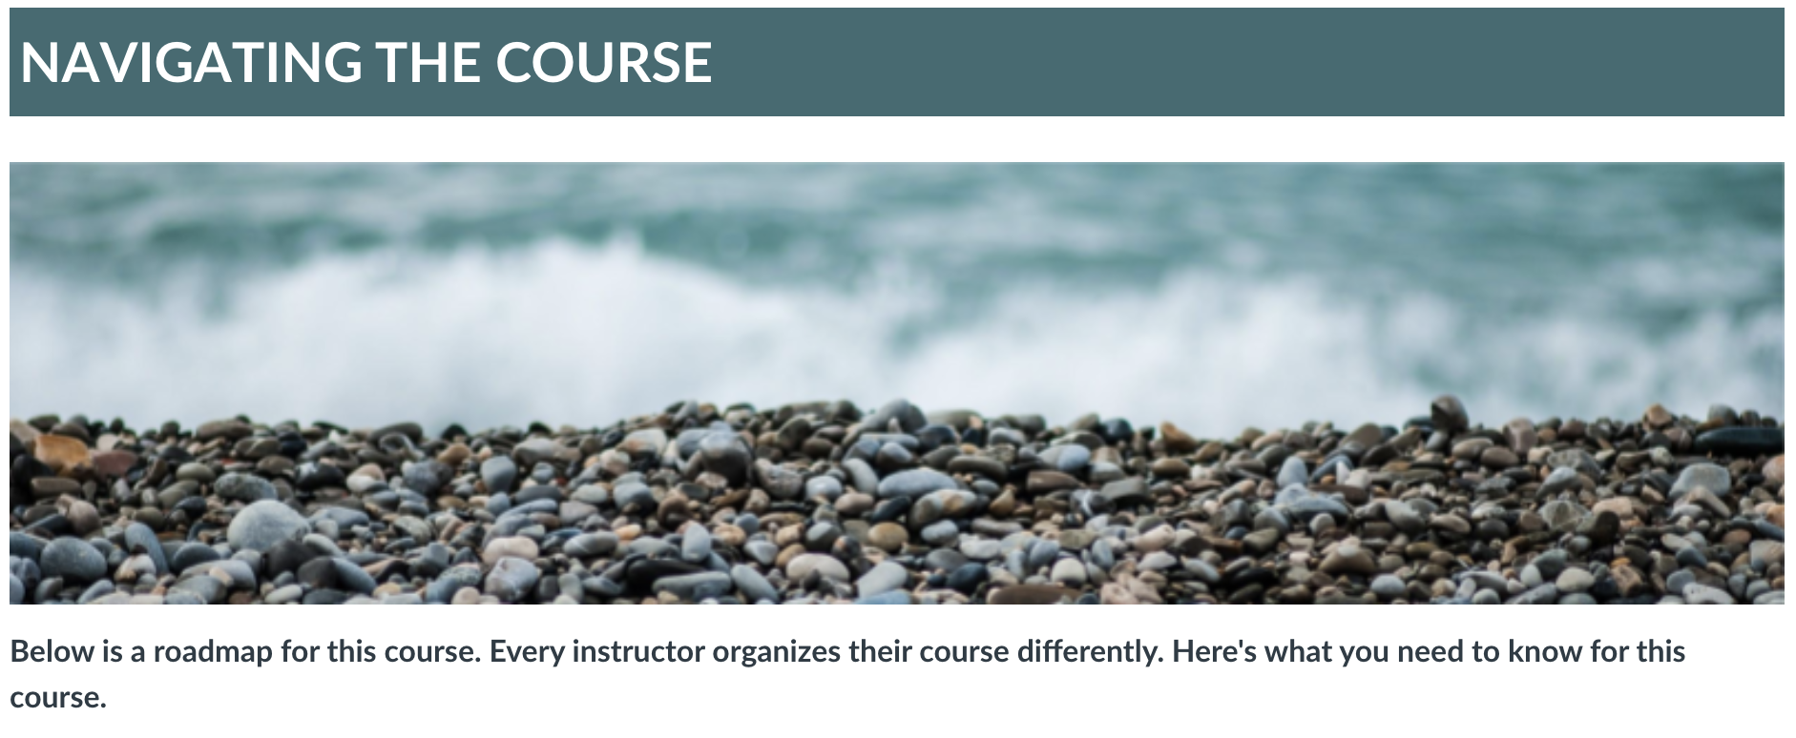
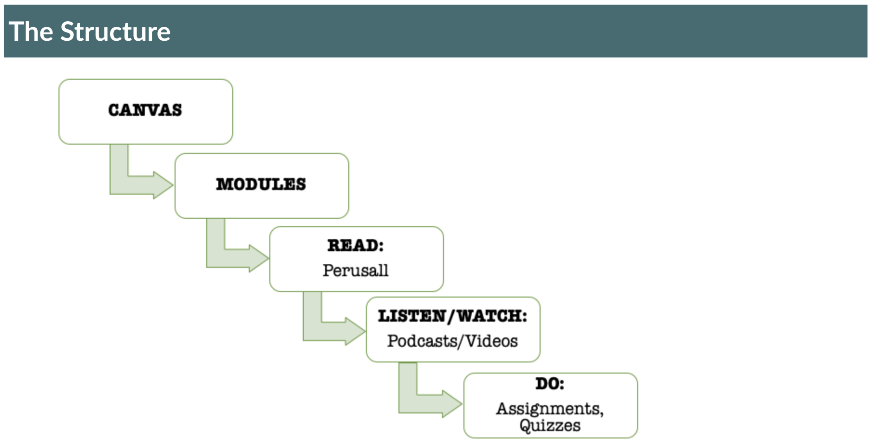

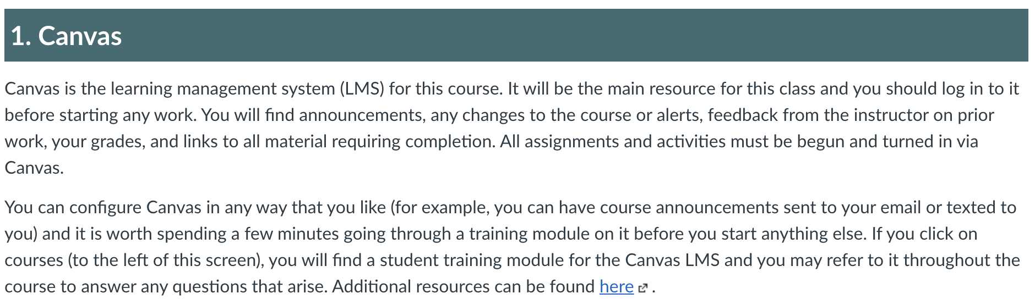

CJ301: Criminal Justice Research Methods Course Structure (2/5)
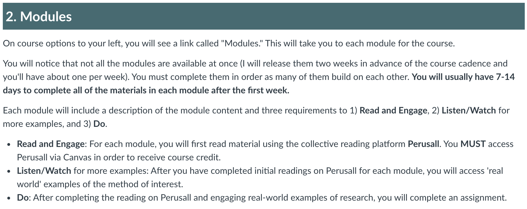

CJ301: Criminal Justice Research Methods Course Structure (3/5)
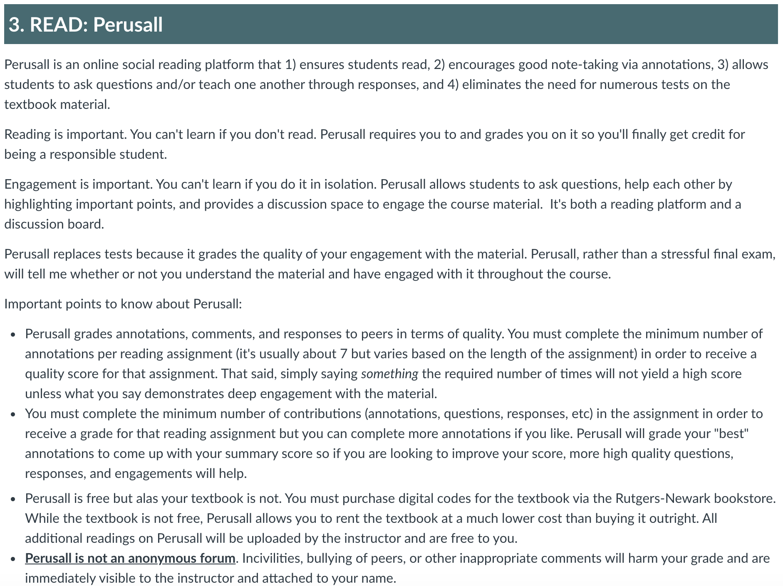

CJ301: Criminal Justice Research Methods Course Structure (4/5)
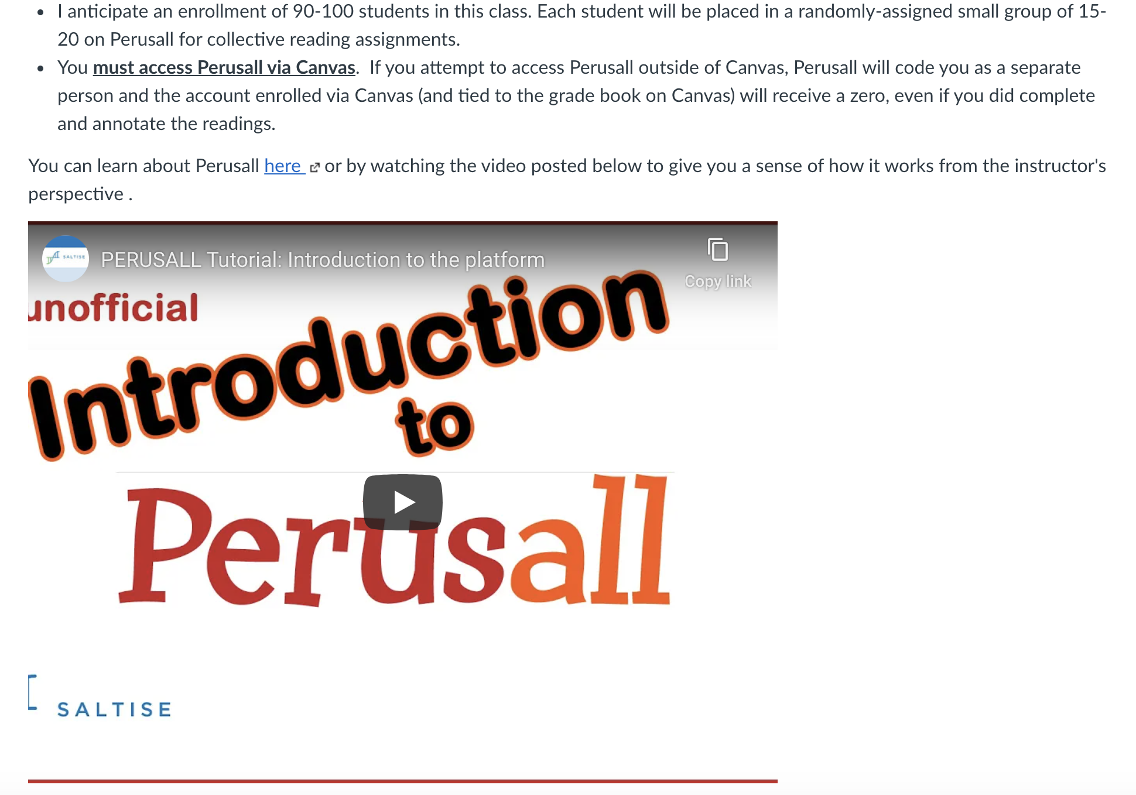

CJ301: Criminal Justice Research Methods Course Structure (5/5)

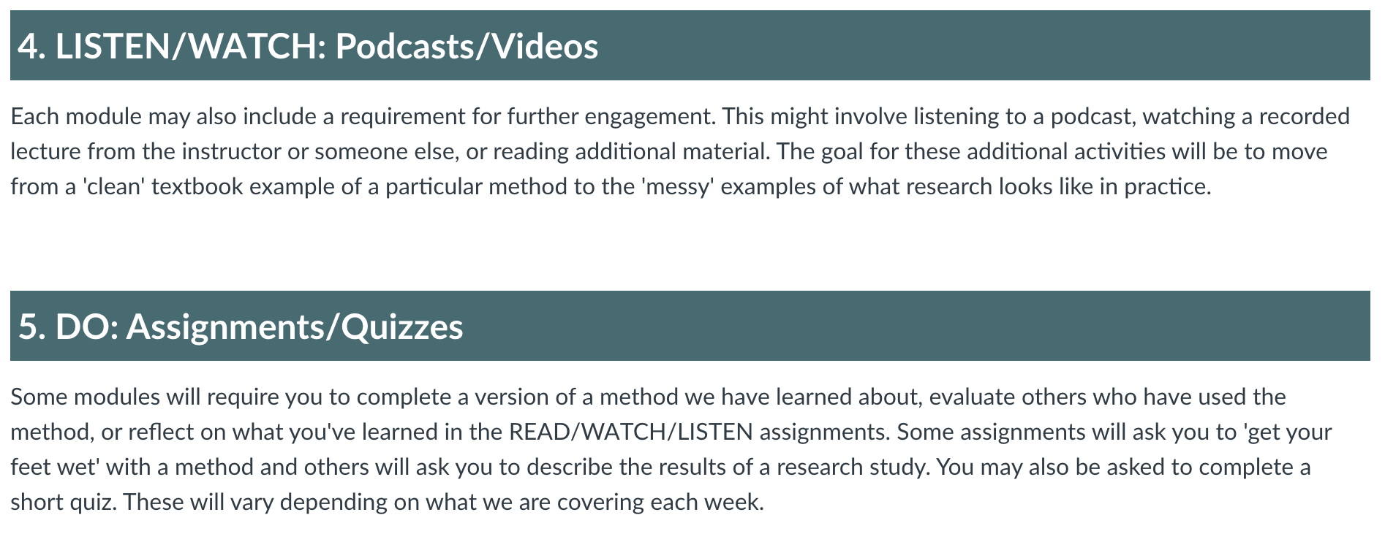

CJ301: Criminal Justice Research Methods Course Policies (1/2)

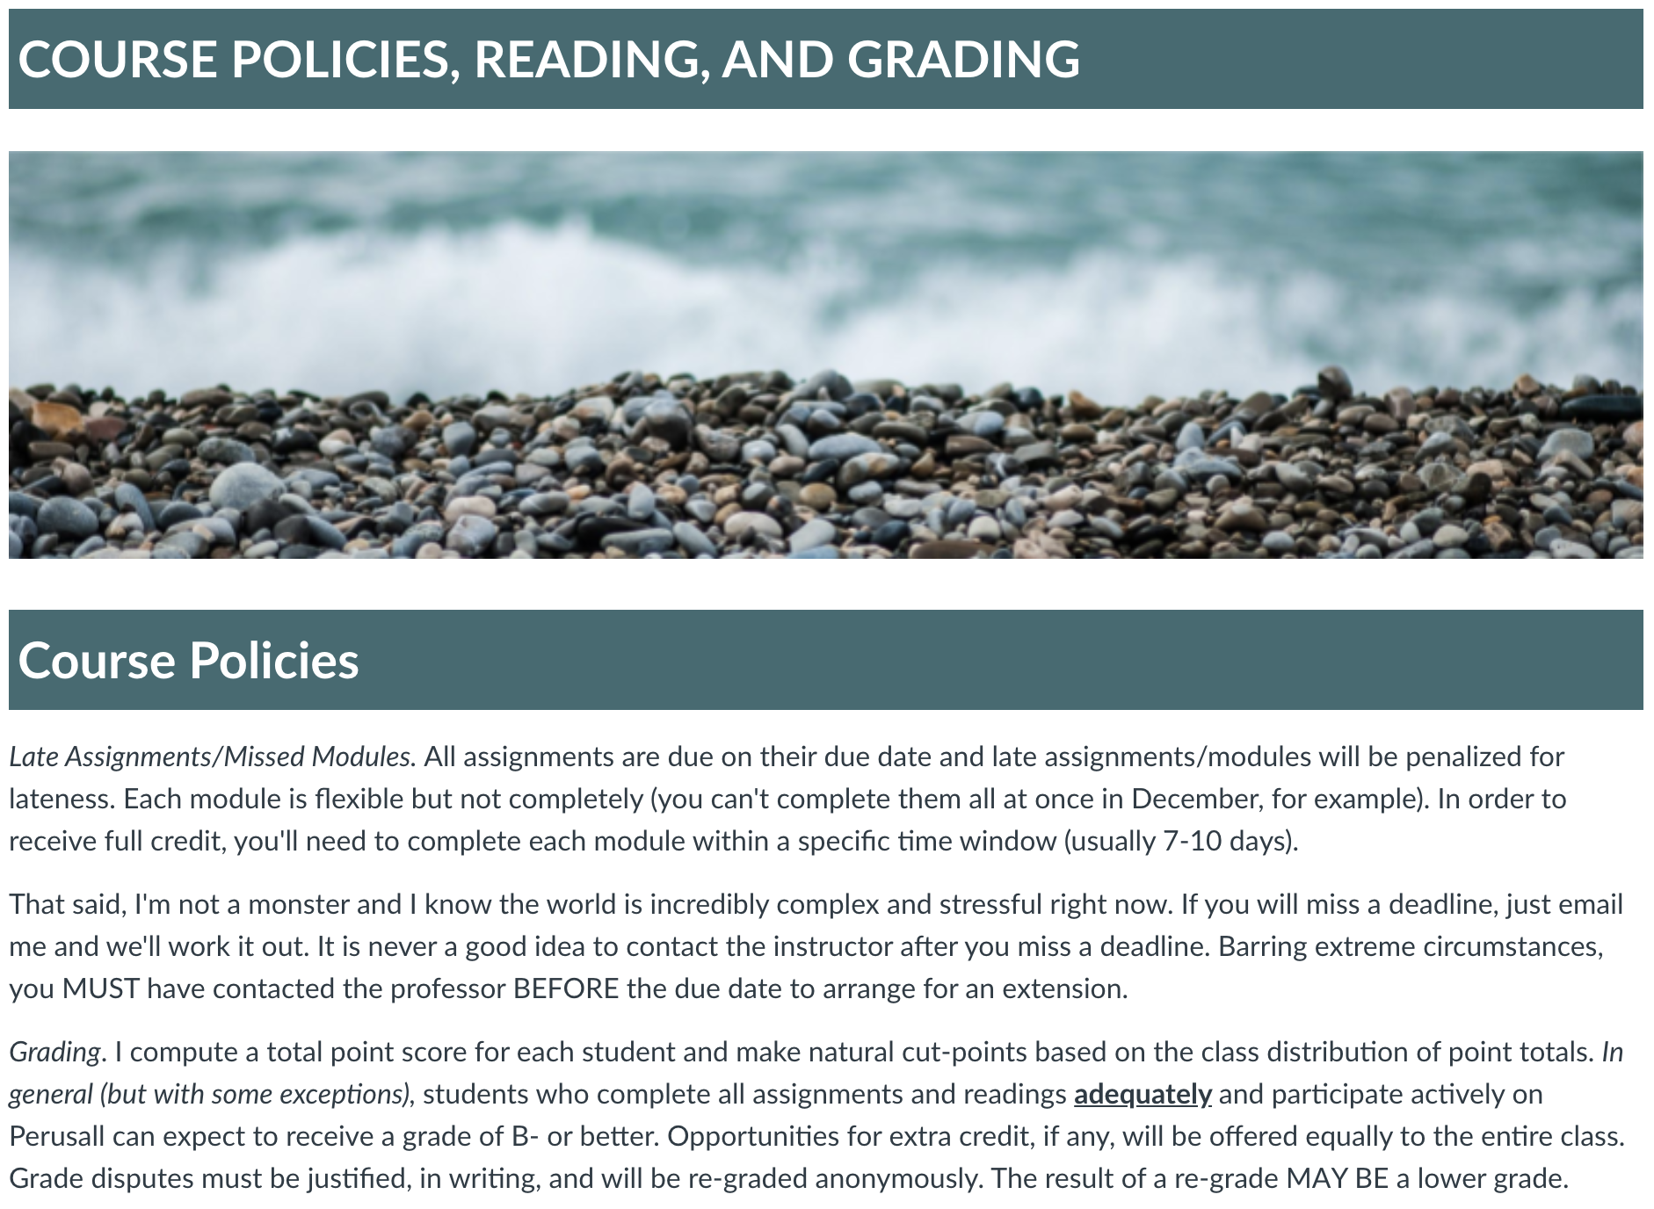
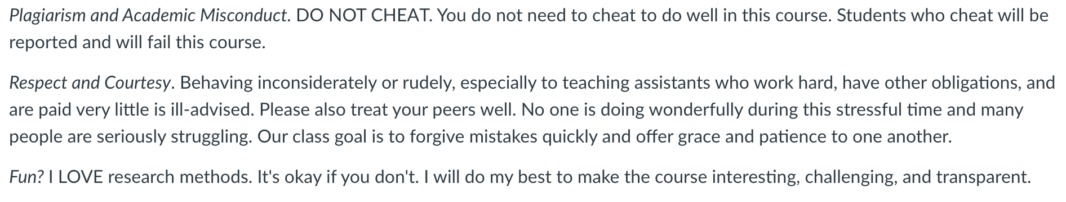

CJ301: Criminal Justice Research Methods Course Policies (2/2)

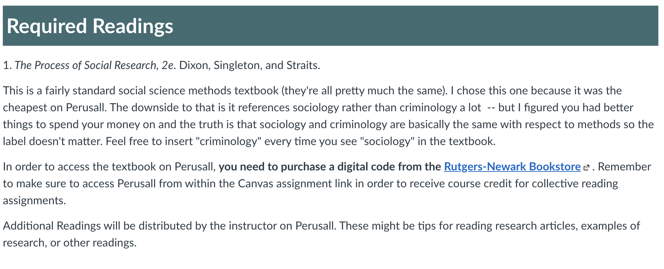

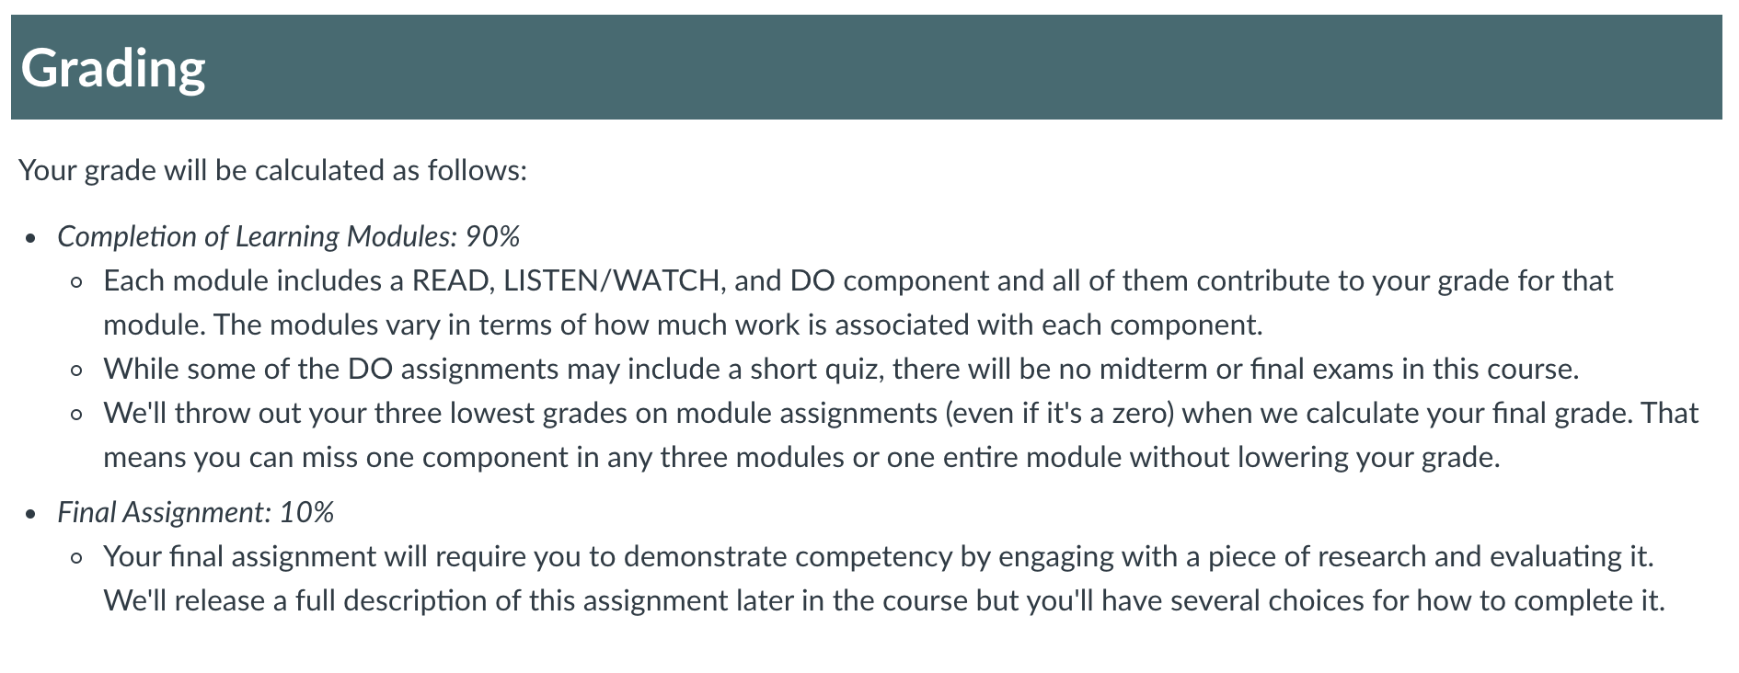

CJ301: Criminal Justice Research Methods Campus Resources (1/2)

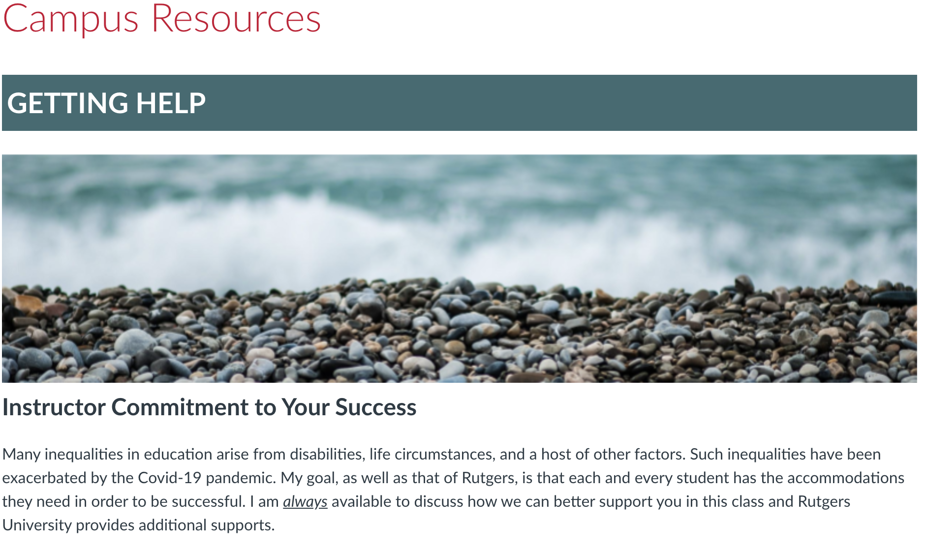

CJ301: Criminal Justice Research Methods Campus Resources (2/2)

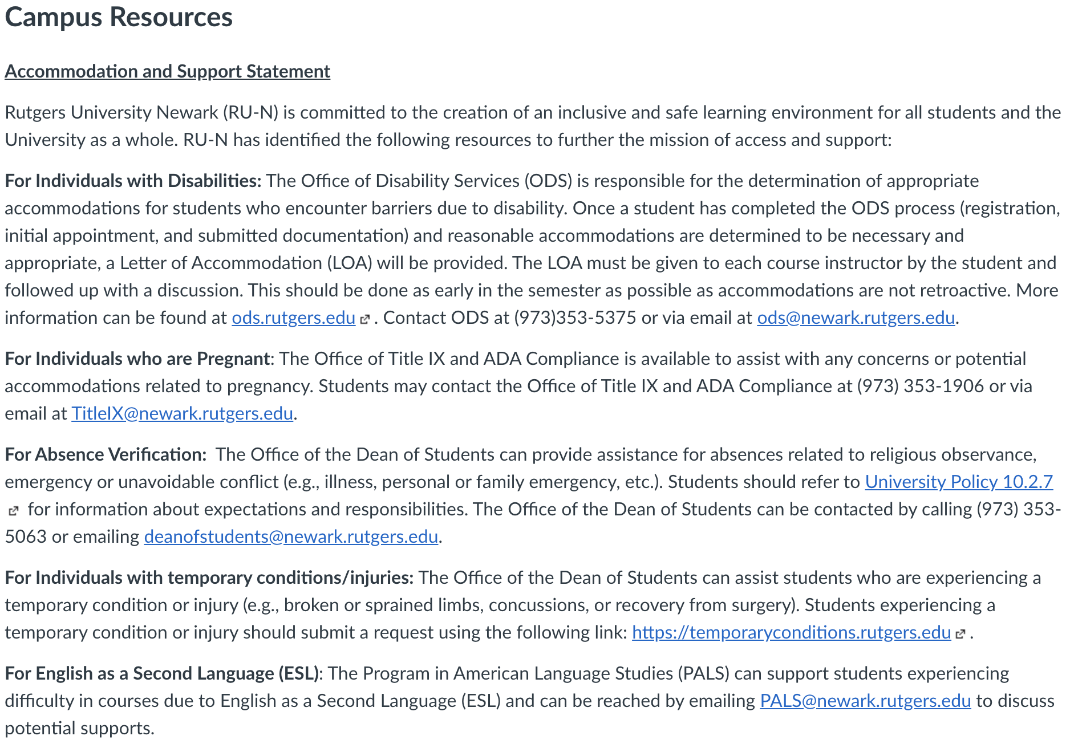

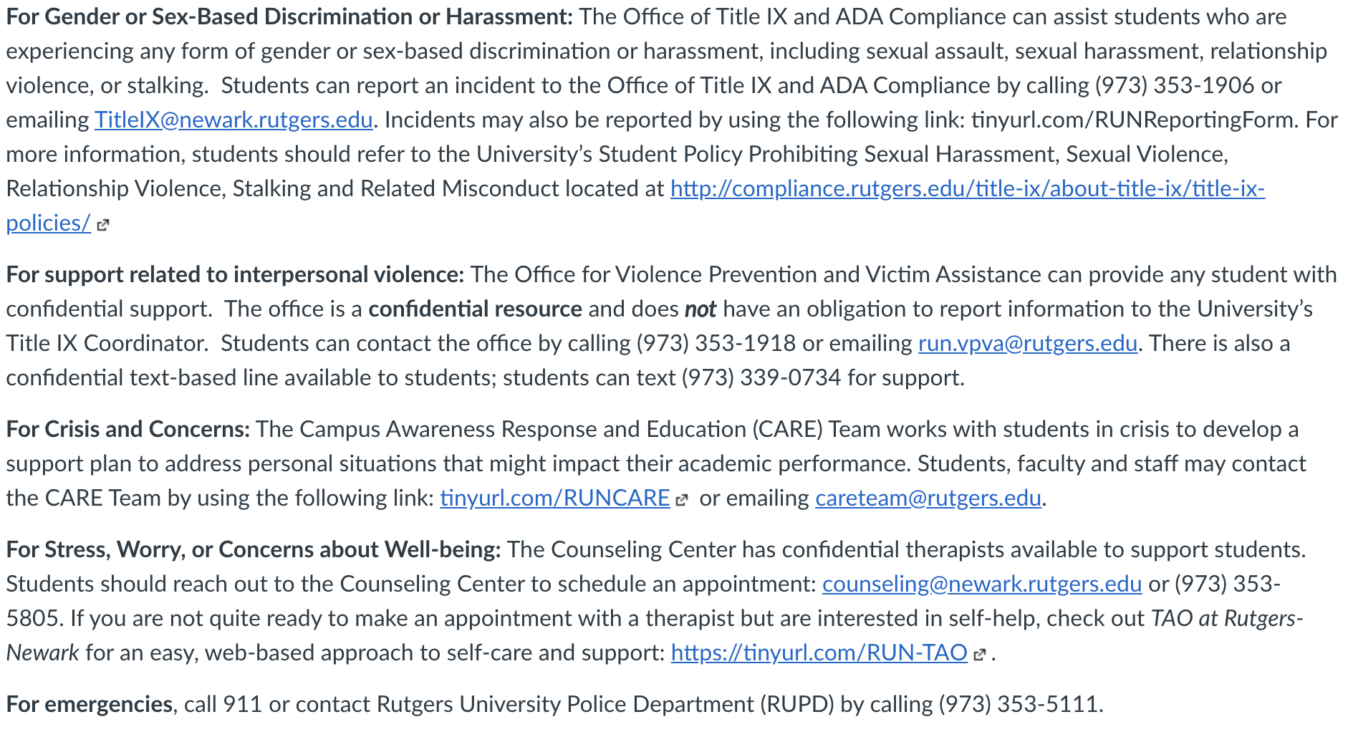
Module and assignment Guide
Module #:Topic | Due Date | Assignments
1: Intro/Syllabus | 9/18 | Syllabus, Perusall #1, Tell Us About Yourself Survey
2: social science | 9/18 | Perusall #2, “How Might I Be Wrong?” Quiz
3: Ethics | 9/25 | Perusall #3, “You be the IRB” Quiz
4:Varieties of Design | 10/2 | Perusall #4, Podcast Lecture, What Is Peer-Reviewed Research, Accessing Research, & Practice Quiz
5: Reading & Understanding Research | 10/16 | Dr. Rubin Reading Guide, Empirical Article, Reading Guide Template Completion Quiz
6: Concepts/Measurement | 10/25 | Perusall #5, Podcast Lecture, Measuring Friendship Quiz, Reliability & Validity Quiz
7: Experiments | 11/1 | Perusall #7, Two podcast lectures
8: Surveys | 11/8 | Perusall #8, Two podcast lectures, Let’s Review Quiz
9: Field Research 1 | 11/15 | Perusall #9, Two podcast lectures (Give Methods a Chance)
10: Field Research 2 | 11/22 | Perusall #10, Podcast, Interviewing Exercise
11: Bringing It All Together | 11/29 | Mini-Lectures, Instructor Meetings
12: Bringing It All Together | 12/6 | Mini-Lectures, Instructor Meetings
***Final Assignment (Critique, infographic, or follow the stat) Due 12/15/2020***

